Instructor Feedback Rating
Alumna College of Engineering wants to allow its students to provide their Feedback Rating for an instructor, online. On submitting the details, the message has to be displayed on the same page as shown in the screen shots below.

Plain Web Page:
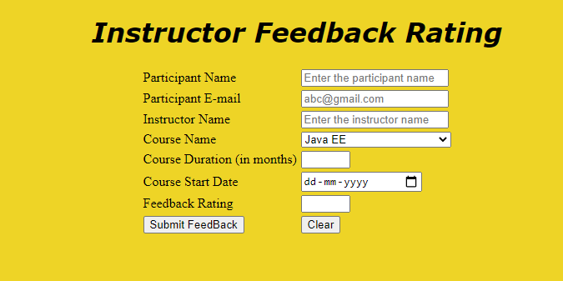

Web page after placing valid data and clicking on Submit Feedback button:

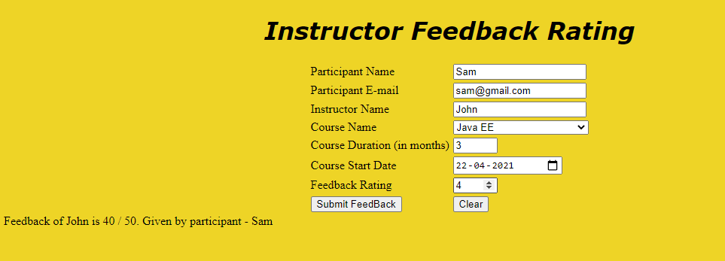

Use the Component Name and the Component Id as given. All the necessary attributes for the Components should be given. The Component Id should be specified for each HTML Component. If the Component Id is not provided for an HTML component, marks will not be provided for that component. All Tags, Elements and Attributes should conform to HTML5 Standards. All the fields are mandatory.

Provide the details as given in the table below.
Req. # | Req. Name | Req. Description
1 | Design an HTML page for “Instructor Feedback Rating” application | Note: The text highlighted in bold in the Description needs to be implemented in the code to complete the web page design.
  Label Name | Component Name and Component Id  (Specify it for the “name” and “id” attributes) | Description
  Participant Name | participantName | To enter the name of the participant.  Design Constraints:  - The text “Enter the participant name” should appear by default.  - It should be mandatory.  - Use type=“text” with pattern attribute to accept the alphabets and space only.
  Participant E-mail | participantEmail | To enter the email id of the participant.  Design Constraints:  - The text “abc@gmail.com” should appear by default.  - It should be mandatory.  - Use type=“email”.
  Instructor Name | instructorName | To enter the instructor name.  Design Constraints:  - The text “Enter the instructor name” should appear by default.  - It should be mandatory.  - Use type=“text” with pattern attribute to accept the alphabets and space only.
  Course Name | courseName | To select the course name.  Design Constraints:  Use drop down box with “Java EE”, “Python”, ”Web Technology”, “Android App Development” and “ASP.Net” as the options.  The field is mandatory.
  Course Duration | courseDuration | To enter the course duration.  Design Constraints:  Provide the input type given below to this component and set it’s min value as 1 and max value as 5.  It should be mandatory.  Use type=“number”
  Course Start Date | courseDate | To enter the course start date.  Design Constraints:  - Use type=“date”  - It should be mandatory.
  Feedback Rating | rating | To enter the feedback rating.  Design Constraints:  Provide the input type given below to this component and set it’s min value as 1 and max value as 5.  It should be mandatory.  Use type=“number” .
   | submit | Submit Button to submit the form  Design Constraints  - The input type should be “submit”.  - Value should be “Submit Feedback”
   | reset | On clicking this button, all fields should be reset. Value should be “Clear”
2 | Apply the mentioned styles using CSS to the components | STYLING WITH ELEMENT SELECTORS  - Body background-color should be “#EED426”  - The heading "Instructor Feedback Rating" should be done using <h1> tag the text color should be “#800080”, style should be “italic” and it should be aligned to center of the webpage. use the font verdana.  Note: Fill in the style tag so as to have the given styles applied to the components. (Do not use Inline CSS)
3 | Use JavaScript for displaying the feedback rating details. | Use JavaScript for displaying the feedback rating details:  When the valid values are entered and the “Submit” button is clicked, the total monthly amount should be displayed as follows:  Result should be displayed as  “"Feedback of "+instructor name+" is "+calculated rating+" / 50. Given by participant - "+participant name ” in a div tag with id as “result”.  use the formula for calculation of feedback as “rating / 5 * 50”  Note:  - Use getElementsByName or getElementById function to retrieve the values.  - Please do not use “let”. Instead, use “var”.
  FeedBack Rating | Value
  Highly Satisfied | 5
  Satisfied | 4
  Neutral | 3
  Dissatisfied | 2
  Highly Dissatisfied | 1
4 | form Tag with attribute onsubmit | form Tag is already given in the code template. Do not change the code template and do the coding as per the requirements and specification.  Make sure that the onsubmit attribute in the form tag invokes the JavaScript function like "return calculateFeedbackRating()".  Also ensure that “return false;” statement is the last line of the JavaScript function “calculateFeedbackRating()”.

